Child Custody Statistics 2004
Single Parent Families with Own Children Under 18
Data source: U.S. Census, America’s Families and Living Arrangements 2004
Current Population Survey, March 2005. Table FG-6.
Highlights and Notes:
- To reflect final custody settlements as accurately as possible, data below include only "never married" and "divorced" families. "Widowed" and "separated" figures are not included.
- Census does not maintain a separate category for joint physical custody. Instead, children are counted as living with the parent where they reside most. For example, if a child lives 60% with the mother and 40% with father, the child is counted as living with the mother. For children who spend equal amounts of time with both parents, the survey counts them as living with the parent where they are found on the day of the survey. Thus half of the children in 50/50 arrangements are recorded as living with their mothers and half as living with their fathers.
- For the total population, divorced single parent families headed by fathers exceeded 20%. Father-headed families increase with income, exceeding 30% at several income levels for white and Hispanic families, and at $100,000 and over for black families.
- White and Hispanic families have similar levels of mother and father-headed famlies across all income categories, while father custody is rare for black families.
- Divorced and never-married families have approximately the same breakdown between mother- and father-headed families.
- Joint physical custody levels cannot be determined from the data, because children are counted with the parent they live with most. For equal custody, in which children spend the same amount of time with father and mother, Census procedures result in children being assigned randomly to either father or mother, so half of 50/50 custody families are counted as headed by fathers and half as headed by mothers. The population of 50/50 custody families can be estimated by the following formula:
J = 2(C - F), where
J = 50/50 joint custody families;
C = percent of families listed by Census as headed by fathers;
F = percent of families where children live more than half time with father .
The best estimator of Fis the percent of children in sole custody of fathers, because joint physical custody assignments that are not 50/50 usually give the majority of time to mothers. Father sole custody families historically have been approximately 9% of single parent families, ranging up to 12% in some states. Based on the 9% estimate, the level of 50/50 custody for divorced families is approximately 2(21 - 9) = 24%. If the level of father sole custody families is 12%, then equal joint custody families are approximately 18% of the total. For never married and divorced families combined, the estimate for 50/50 joint physical custody ranges from approximately 11% to 17%. (See chart below.)
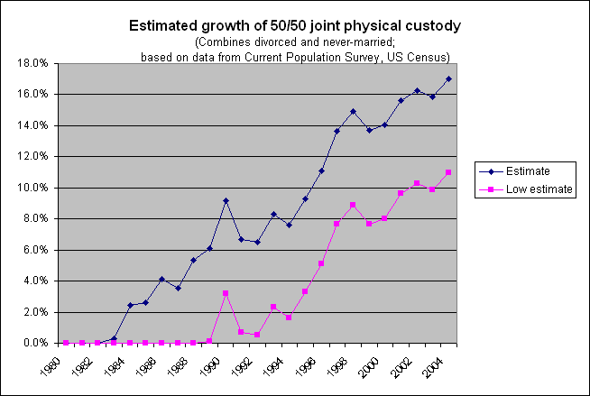
Custody in Single Parent Families by Poverty Level |  | Father |  | Mother
 |  | Number | Percent | Number | Percent
White | Below poverty level | 194 | 13.1% | 1,287 | 86.9%
 | Above poverty level | 991 | 26.7% | 2,716 | 73.3%
Black | Below poverty level | 108 | 10.2% | 952 | 89.8%
 | Above poverty level | 187 | 14.3% | 1,122 | 85.7%
Hispanic | Below poverty level | 85 | 16.2% | 439 | 83.8%
 | Above poverty level | 191 | 26.8% | 522 | 73.2%
Source: U.S. Census, America’s Families and Living Arrangements 2004
Current Population Survey, March 2005. Table FG-6.
(Figures combine never married and divorced families; numbers in thousands)
