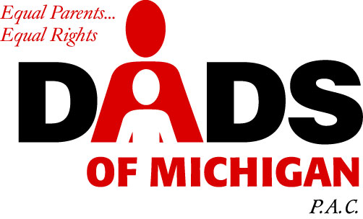
(248) 559-DADS or (800) 781-9247

Contact Your State Legislators & Request Support for:

THE EQUAL PARENTIN BILL – HOUSE BILL 5267

Summarized

The Parental Parity Bill merely amends current law [M.C.L.A. 722.26a] to require Michigan courts to recognize and respect the presumed right of both parents to joint physical and legal custody of their minor children in divorce and custody cases; unless by clear and convincing evidence, one parent is proven unfit.

Realistically and in most instances, this bill would encourage parents to present mutually agreed upon parenting time plans for their minor children to the court for acceptance; failing that, the court would be required to impose a “50/50” joint physical/legal custody parenting plan.

Although the equal, inalienable right of parents to the care, custody, and nurturing of their children is guaranteed and protected by the U.S. Constitution, upheld by numerous U.S. Supreme Court rulings, it is sadly and routinely ignored in over 90% of the divorce and custody cases brought before Michigan family courts!

Please contact your state senator at (517) 373-2400 and your state representative at (517) 373-0135 and let them know…”in most cases, our children need both of their parents actively involved in their lives despite the domestic circumstances of divorce, legal separation, etc…because the best parent is both parents”. Letters should be addressed to:

(your) State Senator (your) State Representative
State Capitol State Capitol
P.O. Box 30036 P.O. Box 30014
Lansing, MI 48909-7536 Lansing, MI 48909-7514

Thank you for your support.

