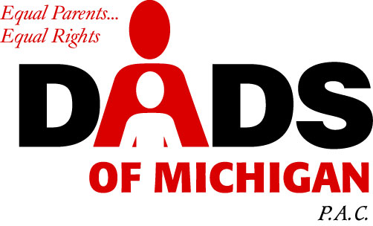
November 14, 2005
DADS of Michigan
26677 W. Twelve Mile Road
Southfield, Michigan 48034
(248) 559-DADS phone
(248) 355-2511 fax
Email: info@dadsofmichigan.org

Representative Mortimer
Michigan House of Representatives
House Office Building
P.O. Box 30014
Lansing, Michigan 48909-7514

Ref : Testimony on House Bill 5267

Honorable Mortimer:

Thank you and your colleagues for introducing HB 5267 on the topic of parental parity.

As we well know, the Michigan judicial system is guided to decide which parent is the better parent. This presumption is that one parent is more fit than the other. The statistics in the Michigan courts have asserted that the Mother is the more fit parent in approximately 90 percent of the cases.

It may appear sensible that children will fare much better in the care and custody of the Mother. However, the mounting statistics over thirty years continues to confirm that children fare much better in the care and custody of both parents, even in the event of divorce. With this preponderance of evidence, which is enormous, it is common sense that we should modify the laws which impede parent involvement in children's lives.

There are numerous publications that support shared parenting and you will find some of the evidence, 'real' statistics, and expert testimony in the following:

Parenting Our Children, Department of Health and Human Services, 1996

Father Facts, 3rd ed., The National Fatherhood Initiative, Wade F. Horn, Ph.D, 1999, ph 301-948-0599

Restoring Fathers to Families and Communities, Social Policy Action Network, Kathleen Sylvester and Kathy Reich, 2000, ph 202-434-4770.

There are many disturbing facts in our social structure that only major surgery in family and children legislation and long rehabilitation can repair.

- The well documented increase of violence, sexual conduct, and incarceration of children in single parent households.
- The high rate of divorce and the devastating affect on the financial well being of all of those affected.
- The high rate of children born out of wedlock, 70% in the City of Detroit
- The affects two parent working households in divorce

In case of divorce, both parents need to work; one to support the child and the other to pay child support. When both parents are working, who takes care of the child? The current system does not encourage or support the non-custodial parent to parent the child while the custodial parent is working. We need to encourage parents to work together, adjust their work schedules, and share in the parenting of the children. This is a win-win situation.

Our legislators need to do everything in their power to give our children all of the support and resources possible. One fantastic resource that we continuously exclude is the parents. When you remove the parents from raising and developing the children, who do you expect to raise children? This practice is unconscionable.

This Bill has been occasionally labeled a Fathers rights bill. However, there are many Mother's that are impeded from having a shared parenting arrangement with their children. Therefore, in fact, this is a Mother's rights bill.

To those who would oppose this common sense bill, you must ask in whose interest do they serve. Clearly, it is not children.

If there is anything Dads of Michigan PAC can do to help and support yours efforts, please do not hesitate to call me at 248-693-0558.

Sincerely,

James Semerad
Chairman

